# Introducing Microsoft BI Reporting and Analysis Tools

**Summary:** Choose the right BI tool by learning about the different strengths of the Microsoft analysis and reporting tools. Microsoft provides a variety of BI tools that can address key workloads, such as Power BI and Excel. The article discusses the workloads and the tools that best support each workload.

To view a mapping of Microsoft BI tools to data analysis and reporting workloads, see [Choosing Microsoft Business Intelligence (BI) Tools for Analysis and Reporting](http://msdn.microsoft.com/en-us/library/d0e16108-7123-4788-87b3-05db962dbc94) (<http://msdn.microsoft.com/en-us/library/d0e16108-7123-4788-87b3-05db962dbc94>).

**Writer:** Carla Sabotta

**Technical Reviewer:** Mike Plumley, Maggie Sparkman, Parikshit Savjani, Jeff Stokes, Jeannine Nelson-Takaki

**Published:** October, 2015

**Applies to:** SQL Server, SharePoint 2013, Excel 2016, Microsoft Azure

Copyright

This document is provided “as-is”. Information and views expressed in this document, including URL and other Internet Web site references, may change without notice. You bear the risk of using it.

Some examples depicted herein are provided for illustration only and are fictitious.  No real association or connection is intended or should be inferred.

This document does not provide you with any legal rights to any intellectual property in any Microsoft product. You may copy and use this document for your internal, reference purposes.

© 2015 Microsoft. All rights reserved.

Contents

Introducing Microsoft BI Reporting and Analysis Tools 1

Introduction 4

Self-Service BI 5

Tool Options 5

Microsoft Excel 6

Power Pivot for Excel 8

Power View for Excel 9

Microsoft 3D Maps for Excel 12

SharePoint 2013 Sites 13

Power BI 14

Power BI Desktop 17

Power BI 17

Data Mining Client for Excel 18

Typical Infrastructure 19

Corporate BI 19

Tool Options 20

Microsoft SQL Server Analysis Services 20

Microsoft SQL Server Reporting Services 21

Power View for SharePoint 2013 24

SharePoint 2013 Dashboards 25

PerformancePoint Services 26

Typical Infrastructure 27

BI and Microsoft Azure Technologies 27

Azure Machine Learning 27

Azure Stream Analytics 29

Cortana Analytics Suite 31

Advanced Analytics 31

Tool Options 31

Data Mining Client for Excel 31

Data Mining in Analysis Services 32

Conclusion 32

# Introduction

The intent of this article is to assist you with choosing the business intelligence (BI) tools that meet your organization’s BI needs. Microsoft provides a variety of BI tools that can address key workloads. The article discusses the workloads and the tools that best support each workload.

To view a mapping of Microsoft BI tools to data analysis and reporting workloads, see [Choosing Microsoft Business Intelligence (BI) Tools for Analysis and Reporting](http://msdn.microsoft.com/en-us/library/d0e16108-7123-4788-87b3-05db962dbc94) (http://msdn.microsoft.com/en-us/library/d0e16108-7123-4788-87b3-05db962dbc94).

The following are the workloads.

* **Self-Service BI** – Involves free-form reporting and analysis that enables you to integrate data from disparate sources and drill-down and understand the root cause for data anomalies. You can perform your own reporting and analysis without relying on IT or others.
* **Corporate BI** – Involves formatted reports that are typically based upon approved corporate data, and then shared more broadly with managers, teams, or departments. IT oversees the distribution and monitoring of the reporting environment and building of the structured data layer upon which the reports are built. Reports are authored and managed by IT and usually follow a pixel perfect format and rendering style

One type of report is dashboard reports. Dashboard reports allow you to monitor the performance and health of your business, often permitting further investigation via interactivity.

Another type of report is scorecards. Scorecards are highly summarized views with Key Performance Indicators (or KPIs) measured and scored against predefined targets such as a balanced scorecard. These reports are generally a part of a performance management program, though they can also be used to measure operational performance.

* **Advanced Analytics** – Involves tools and techniques that are used to forecast future outcomes and behaviors. Data mining and predictive analytics are some of the analytical categories that are part of advanced analytics.

Data mining uses mathematical analysis to derive patterns and trends that exist in data. Typically, these patterns cannot be discovered by traditional data exploration because the relationships are too complex or because there is too much data. These patterns and trends can be collected and defined as a data mining model.

The following are the tools.

* Microsoft Excel
  + Power Pivot
  + Power View
  + 3D Maps
  + Data Mining Client for Excel
* SharePoint 2013 Sites
  + Power View for SharePoint 2013
  + SharePoint 2013 Dashboards
  + PerformancePoint Services in SharePoint 2013
* Power BI
  + Q & A
  + Power BI Apps for Mobile Devices
  + Groups
  + Data Catalog
  + Excel Workbooks
* Power BI Desktop
* SQL Server Analysis Services
  + Data Mining in Analysis Services
* SQL Server Reporting Services

# Self-Service BI

Self-service BI involves data analysis and reporting without reliance on IT. The following are some key characteristics:

* Users are familiar with the business data and have strong Excel skills, and have minimal specialized technical skills such as SQL, MDX, or other query languages.
* Users want to easily drill down, pivot, filter, and format the data.
* Frequently information is integrated from a variety of sources, and data sources can include corporate sanctioned and IT managed data sources.
* Frequently small-to-medium sized data sets are used.
* Distributing the information on a regular basis is not typically the primary purpose, although the analysis might be shared with others.

## Tool Options

The following tools support self-service BI.

* Microsoft Excel
  + Power Pivot
  + Power View
  + 3D Maps
  + Data Mining add-Ins for Excel
* SharePoint 2013 Sites
* Power BI
  + Q & A
  + Power BI Apps for Mobile Devices
  + Groups
  + Data Catalog
  + Excel Workbooks
* Power BI Desktop

### Microsoft Excel

Microsoft Excel enables you to collect and analyze data, and to develop reports. Excel Services enables you to render a workbook in a browser window and refresh the associated data connection. Others have access to the workbook or specific parts of it without being able to modify the workbook or calculations, thereby ensuring a single version of the workbook is maintained and viewed by everyone.

With an Excel Services workbook you can also perform live, interactive analysis through any supported browser, including sorting and filtering of data, as well as expanding or collapsing of PivotTables.

#### Excel 2016

Excel 2016 for Windows has all the functionality and features you're used to with some added features and enhancements. Several of the top new and improved features include the following.

* New chart types to help you create some of the most commonly used data visualizations of financial or hierarchal information, or for revealing statistical properties in your data. The new chart types include Treemap, Sunburst, Waterfall, Histogram, Pareto, and Box and Whisker.

|  |  |  |
| --- | --- | --- |
|  |  |  |

* Built-in functionality that makes it easy to quickly get and transform your data. These new capabilities, previously only available as a separate add-in called Power Query, can be found natively within Excel.

|  |
| --- |
|  |

* The FORECAST function has been extended to allow forecasting based on Exponential Smoothing. This functionality is also available as a new one-click **Forecast Sheet** button.

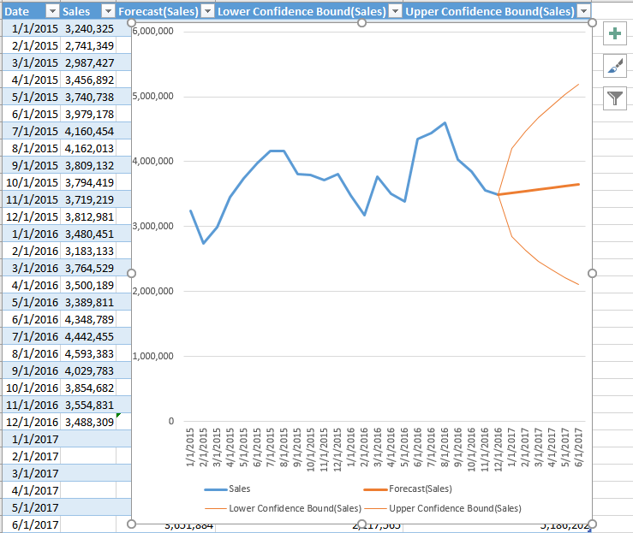

* There are enhancements to the PivotTable authoring environment, such as automatic relationship detection, automatic time grouping, and field searching.
* Select multiple items in an Excel slicer on a touch device.
* Share your data analysis with your workgroup or clients by publishing to Power BI with one button and then use your data models to quickly construct interactive reports and dashboards.
* The **Tell me what you want to do** text field enables you to enter words and phrases related to what you want to do next and quickly get to features you want to use or actions you want to perform. You can also choose to get help related to what you're looking for, or perform a Smart Lookup on the term you entered.
* With **Smart Lookup**, you can quickly locate definitions, Wiki articles, and top Web search results related to a selected word or phrase.
* With **Ink Equation** you can use your finger, touch stylus, or a mouse to write math equations by hand, and Excel will convert it to text.
* You can share your spreadsheet with others on SharePoint, OneDrive, or OneDrive for Business, and use **History** to see a complete list of changes that have been made to your workbook and access earlier versions.
* Data Loss Protection (DLP) is introduced in Excel to enable real time scan of content based on a set of predefined policies for the most common sensitive data types.

For more information, see the following articles.

* [What’s new in Excel 2016 for Windows](https://support.office.com/en-us/article/What-s-new-in-Excel-2016-for-Windows-5fdb9208-ff33-45b6-9e08-1f5cdb3a6c73?ui=en-US&rs=en-US&ad=US) (https://support.office.com/en-us/article/What-s-new-in-Excel-2016-for-Windows-5fdb9208-ff33-45b6-9e08-1f5cdb3a6c73?ui=en-US&rs=en-US&ad=US)
* [Create a forecast in Excel 2016 for Windows](https://support.office.com/en-us/article/Create-a-forecast-in-Excel-2016-for-Windows-22c500da-6da7-45e5-bfdc-60a7062329fd) (<https://support.office.com/en-us/article/Create-a-forecast-in-Excel-2016-for-Windows-22c500da-6da7-45e5-bfdc-60a7062329fd>)
* [Getting Started with Get & Transform in Excel 2016](https://support.office.com/en-us/article/Getting-Started-with-Get-Transform-in-Excel-2016-a8310388-2a12-438c-9d29-c6d29cb8df6a?ui=en-US&rs=en-US&ad=US) (https://support.office.com/en-us/article/Getting-Started-with-Get-Transform-in-Excel-2016-a8310388-2a12-438c-9d29-c6d29cb8df6a?ui=en-US&rs=en-US&ad=US)

### Power Pivot for Excel

Power Pivot is a data modeling technology that lets you create data models, establish relationships, and create calculations. You can work with large data sets, build extensive relationships, and create complex (or simple) calculations, within the familiar experience of Excel.

With Power Pivot you can filter data and rename columns and tables while importing the data, and create perspectives to limit the number of columns and tables that your workbook consumers see. You can write advanced formulas with the Data Analysis Expressions (DAX) expression language. You can create key performance indicators (KPIs) to use in PivotTables and Power View reports.

You can create a relationship between two tables of data, based on matching data in each table, even when the tables are from different sources. The following Diagram view in Power Pivot shows relationships between several tables.

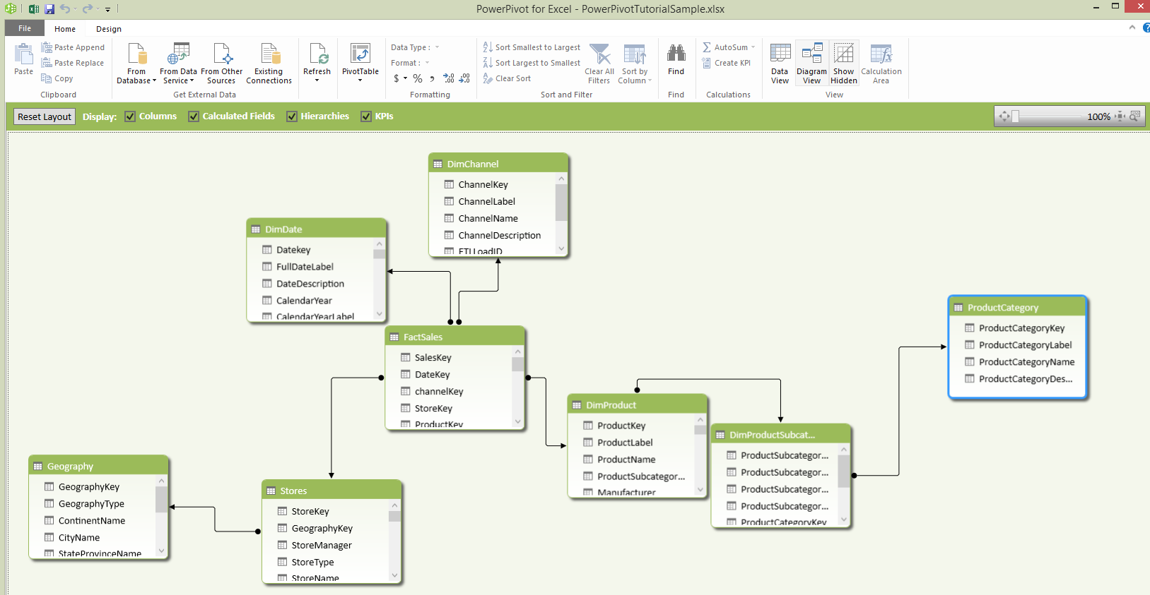

You can also use Power Pivot to prototype the solution quickly before involving IT in building more traditional BI infrastructure like a formal SQL Server Analysis Services cube.

For more information, see the following articles.

* [Power Pivot – Overview and Learning](https://support.office.com/en-us/article/Power-Pivot-Overview-and-Learning-f9001958-7901-4caa-ad80-028a6d2432ed?ui=en-US&rs=en-US&ad=US) (https://support.office.com/en-us/article/Power-Pivot-Overview-and-Learning-f9001958-7901-4caa-ad80-028a6d2432ed?ui=en-US&rs=en-US&ad=US)
* [Power Pivot: Powerful data analysis and data modeling in Excel](http://office.microsoft.com/en-us/excel-help/powerpivot-powerful-data-analysis-and-data-modeling-in-excel-HA102837110.aspx) (<http://office.microsoft.com/en-us/excel-help/powerpivot-powerful-data-analysis-and-data-modeling-in-excel-HA102837110.aspx>)
* [Data Model specification and limits (Excel workbooks)](http://office.microsoft.com/en-us/excel-help/data-model-specification-and-limits-HA102837464.aspx?CTT=5&origin=HA102893837) (<http://office.microsoft.com/en-us/excel-help/data-model-specification-and-limits-HA102837464.aspx>)
* [Create a Data Model in Excel](https://support.office.com/en-us/article/Create-a-Data-Model-in-Excel-87e7a54c-87dc-488e-9410-5c75dbcb0f7b) (<https://support.office.com/en-us/article/Create-a-Data-Model-in-Excel-87e7a54c-87dc-488e-9410-5c75dbcb0f7b>)
* [QuickStart: Learn DAX Basics in 30 Minutes](https://support.office.com/en-us/article/QuickStart-Learn-DAX-Basics-in-30-Minutes-51744643-c2a5-436a-bdf6-c895762bec1a) (https://support.office.com/en-us/article/QuickStart-Learn-DAX-Basics-in-30-Minutes-51744643-c2a5-436a-bdf6-c895762bec1a)

### Power View for Excel

Power View is a data visualization technology that lets you create interactive charts, graphs, maps, and other visuals that bring your data to life. Power View is available in Excel, in SharePoint, SQL Server, and Power BI. The visualizations in Power View are also available in Power BI and the Power BI Desktop.

The following images show some of the different types of data visualizations that you can add to a Power View report. The data shown in each visualization is USA 2011 Car Crash Data. The data source is the Fatality Analysis Reporting System (FARS) Encyclopedia.

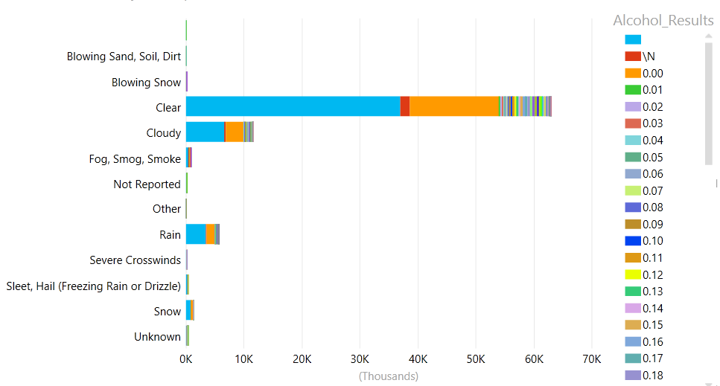

Figure -- Power View Bar Chart

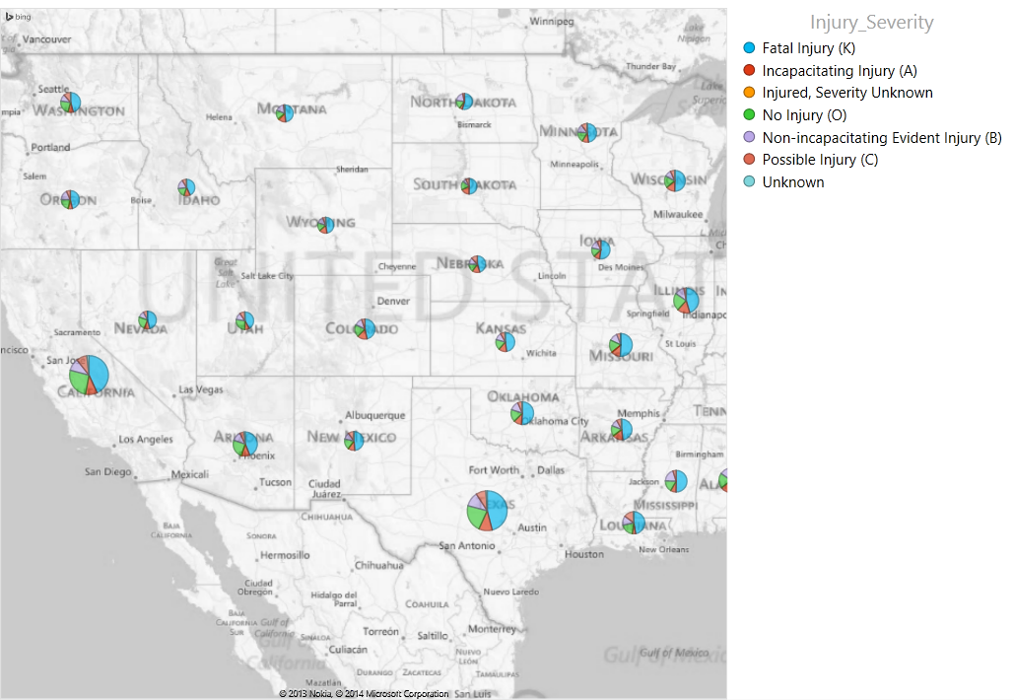

Figure -- Power View Map

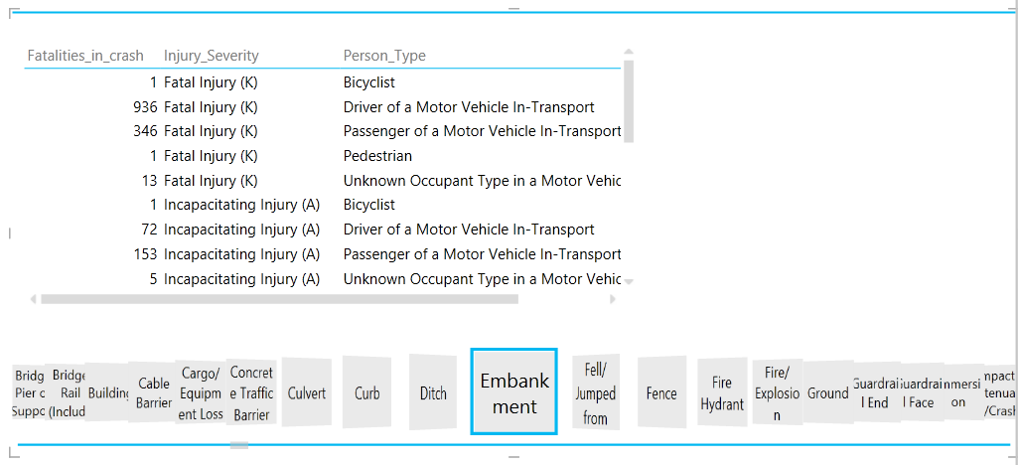

Figure -- Power View Tiles

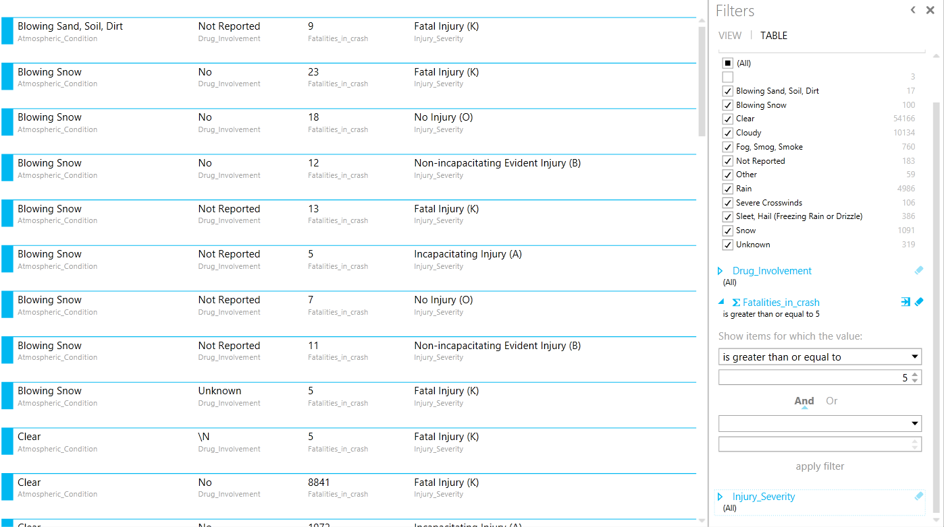

Figure -- Power View Card with Filters

You can view Power View in Excel sheets in your browser without installing Silverlight. Some of the new features of Power View in HTML5 include the following.

* More data in visualizations. For most types of chart, each chart can now show up to 30,000 data points.
* Switch between Silverlight and HTML5 version of Power View.
* Maps can show multiple series of data, so not just dots but also pie charts of various sizes on maps.
* Now available in nine languages.

For more information, see [HTML5 version of Power View](http://office.microsoft.com/en-us/office365-sharepoint-online-enterprise-help/power-view-in-html5-HA104102908.aspx?CTT=5&origin=HA102835634) (<http://office.microsoft.com/en-us/office365-sharepoint-online-enterprise-help/power-view-in-html5-HA104102908.aspx?CTT=5&origin=HA102835634>) and [What’s new in Power View in HTML5](https://support.office.com/en-us/article/What-s-new-in-Power-View-in-HTML5-cd6939f2-956c-4482-9b70-ebd9837d9881?ui=en-US&rs=en-US&ad=US) (https://support.office.com/en-us/article/What-s-new-in-Power-View-in-HTML5-cd6939f2-956c-4482-9b70-ebd9837d9881?ui=en-US&rs=en-US&ad=US).

For additional information about Power View, see the following articles.

* [Turn on Power View in Excel 2016 for Windows](https://www.support.office.com/en-US/article/Turn-on-Power-View-in-Excel-2016-for-Windows-f8fc21a6-08fc-407a-8a91-643fa848729a) (https://www.support.office.com/en-US/article/Turn-on-Power-View-in-Excel-2016-for-Windows-f8fc21a6-08fc-407a-8a91-643fa848729a)
* [Power View: Explore, visualize, and present your data](https://support.office.com/en-us/article/Power-View-Explore-visualize-and-present-your-data-98268d31-97e2-42aa-a52b-a68cf460472e) (<https://support.office.com/en-us/article/Power-View-Explore-visualize-and-present-your-data-98268d31-97e2-42aa-a52b-a68cf460472e>)
* [Tutorial: Create Amazing Power View Reports – Part 1](https://support.office.com/en-us/article/Tutorial-Create-Amazing-Power-View-Reports-Part-1-e2842c8f-585f-4a07-bcbd-5bf8ff2243a7?ui=en-US&rs=en-US&ad=US) (<https://support.office.com/en-us/article/Tutorial-Create-Amazing-Power-View-Reports-Part-1-e2842c8f-585f-4a07-bcbd-5bf8ff2243a7?ui=en-US&rs=en-US&ad=US>)
* [Tutorial: Create Amazing Power View Reports – Part 2](https://support.office.com/en-us/article/Tutorial-Create-Amazing-Power-View-Reports-Part-2-361b1fca-4429-42a2-94a2-e4d5f3e7d170?ui=en-US&rs=en-US&ad=US) (<https://support.office.com/en-us/article/Tutorial-Create-Amazing-Power-View-Reports-Part-2-361b1fca-4429-42a2-94a2-e4d5f3e7d170?ui=en-US&rs=en-US&ad=US>)
* [Tutorial: Optimize your Data Model for Power View Reporting](https://support.office.com/en-us/article/Tutorial-Optimize-your-Data-Model-for-Power-View-reporting-f967bdca-ef91-4c05-b4b9-cf06917ba16e) (<https://support.office.com/en-us/article/Tutorial-Optimize-your-Data-Model-for-Power-View-reporting-f967bdca-ef91-4c05-b4b9-cf06917ba16e>)
* [Tutorial: Create a Power View report with Azure Marketplace data](https://support.office.com/en-us/article/Tutorial-Create-a-Power-View-report-with-Azure-Marketplace-data-3e34ff9f-a520-42df-ab30-fb95af3071d0) (https://support.office.com/en-us/article/Tutorial-Create-a-Power-View-report-with-Azure-Marketplace-data-3e34ff9f-a520-42df-ab30-fb95af3071d0)
* [Data Model specification and limits](http://office.microsoft.com/en-us/excel-help/data-model-specification-and-limits-HA102837464.aspx) (http://office.microsoft.com/en-us/excel-help/data-model-specification-and-limits-HA102837464.aspx)

### Microsoft 3D Maps for Excel

Power Map, the 3-D geospatial visualization add-in for Excel 2013, is now fully integrated into Excel 2016. You'll find 3D Maps alongside other visualization features on the **Insert** tab.

Microsoft 3D Maps for Excel is a three-dimensional (3-D) data visualization tool that lets you look at information in new ways. 3D Maps lets you discover insights you might not see in traditional two-dimensional (2-D) tables and charts.

The data shown in the following example is energy output capacity for U.S. counties, zoomed in to show this data in more detail for certain states such as California and Arizona. The data source is U.S. Energy Information Administration (EIA).

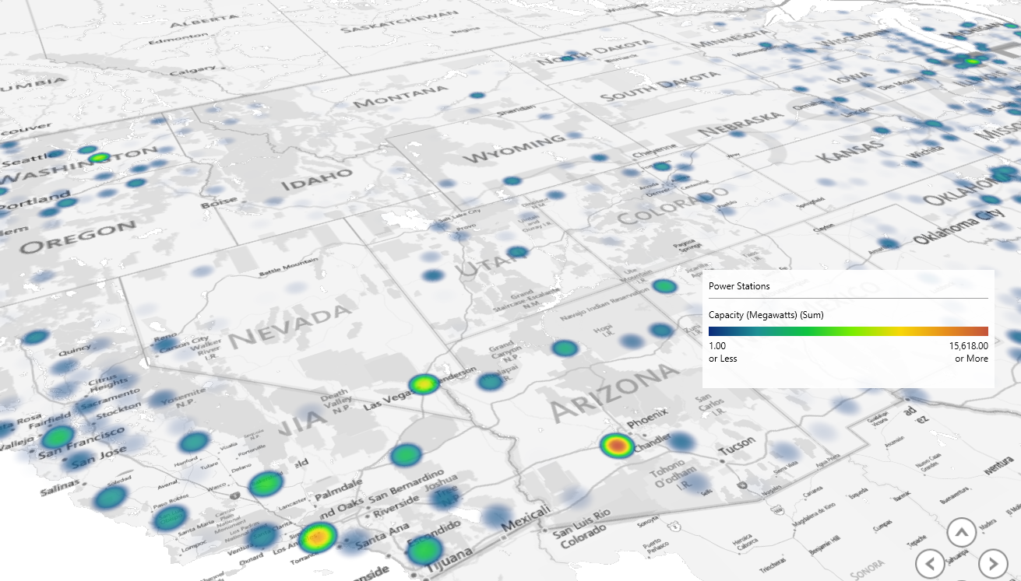

3D Maps include the following features.

* Plot more than a million rows of data visually on Bing maps in 3-D format from an Excel table or Data Model in Excel.
* Gain new understandings by viewing your data in geographic space and seeing time-stamped data change over time.
* Capture screenshots and build cinematic, guided video tours you can share broadly, engaging audiences like never before. Or export tours to video and share them that way as well.

For more information, see [Get started with 3D Maps](https://support.office.com/en-us/article/Get-started-with-3D-Maps-6b56a50d-3c3e-4a9e-a527-eea62a387030) (https://support.office.com/en-US/article/Get-started-with-3D-Maps-6b56a50d-3c3e-4a9e-a527-eea62a387030).

### SharePoint 2013 Sites

Organizations use SharePoint 2013 to create websites. You can use it as a secure place to store, organize, share, and access information from almost any device.

You can also use SharePoint to work with others, organize your projects and teams, and discover people and information.

The following some of the types of sites that you can create.

* **BI Center Sites**: A basic SharePoint 2013 site that contains a set of prebuilt lists and libraries to organize BI content. For more information, see [Create, share, and consume BI content in a BI Center site](http://office.microsoft.com/en-us/office365-sharepoint-online-enterprise-help/create-share-and-consume-bi-content-in-a-bi-center-site-HA104046017.aspx?CTT=5&origin=HA104060713) (<http://office.microsoft.com/en-us/office365-sharepoint-online-enterprise-help/create-share-and-consume-bi-content-in-a-bi-center-site-HA104046017.aspx>), and [Set up a Business Intelligence Center site](http://office.microsoft.com/en-us/sharepoint-server-help/set-up-a-business-intelligence-center-site-HA104046016.aspx?CTT=1) (http://office.microsoft.com/en-us/sharepoint-server-help/set-up-a-business-intelligence-center-site-HA104046016.aspx).
* **Document Center Sites**: Sites that are for large-scale document management. SharePoint includes the Document Center site template. Key features such as document versions, document IDs, document sets, metadata navigation, and content types are built in to the template for you. For more information, see [Use a Document Center site](http://office.microsoft.com/en-us/sharepoint-server-help/use-a-document-center-site-HA102773263.aspx?CTT=1) (http://office.microsoft.com/en-us/sharepoint-server-help/use-a-document-center-site-HA102773263.aspx).

For more information, see the following articles.

* [Best practices for creating and managing team sites](http://office.microsoft.com/en-us/office365-sharepoint-online-enterprise-help/best-practices-for-creating-and-managing-team-sites-HA102779556.aspx?CTT=5&origin=HA103047055) (<http://office.microsoft.com/en-us/office365-sharepoint-online-enterprise-help/best-practices-for-creating-and-managing-team-sites-HA102779556.aspx>)
* [Build sites for SharePoint 2013](http://msdn.microsoft.com/en-us/library/office/jj163242.aspx) (http://msdn.microsoft.com/en-us/library/office/jj163242.aspx)
* [Find content about SharePoint Server 2013](http://office.microsoft.com/en-us/sharepoint-help/find-content-about-sharepoint-server-2013-HA103047055.aspx?CTT=1) (<http://office.microsoft.com/en-us/sharepoint-help/find-content-about-sharepoint-server-2013-HA103047055.aspx> )

### Power BI

There is a new Power BI experience that will lead to the deprecation of existing Power BI for Office 365 experiences and licenses. For information on how migrating from Power BI for Office 365 to the new Power BI experience, see [Migrating to the new Power BI experience](https://support.powerbi.com/knowledgebase/articles/492388) (<https://support.powerbi.com/knowledgebase/articles/492388>).

The new Power BI experience includes the following …

* **Q & A**: Use Q&A to explore your data using intuitive, natural language capabilities and receive answers in the form of interactive charts and graphs. For more information, see [Q&A in Power BI](https://support.powerbi.com/knowledgebase/articles/474566) (https://support.powerbi.com/knowledgebase/articles/474566).

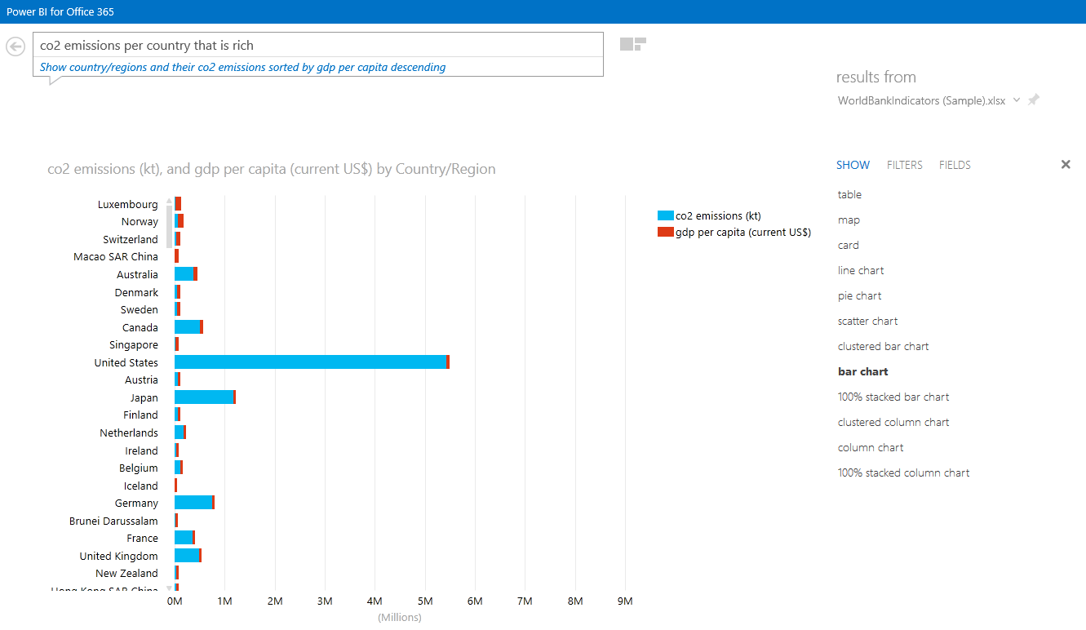

Figure – Results Returned by Power BI Q & A

* **Power BI apps for mobile devices**: You have several options for viewing your Power BI dashboards on your mobile device, including viewing them in a browser on your phone or iPad. And, you can also download a Power BI app to specific devices, including an IPad app, iPhone app, Power BI app for Windows devices, and Power BI app for Android phones.

The iPad app and iPhone app for Microsoft Power BI for iOS brings the mobile BI experience to Power BI. With live, touch-enabled mobile access to your important business information, you can view and interact with your company dashboards and reports easily, from anywhere.

With Microsoft Power BI for Windows app you can view and interact with your company dashboards and reports easily from anywhere and share them with your colleagues in email.

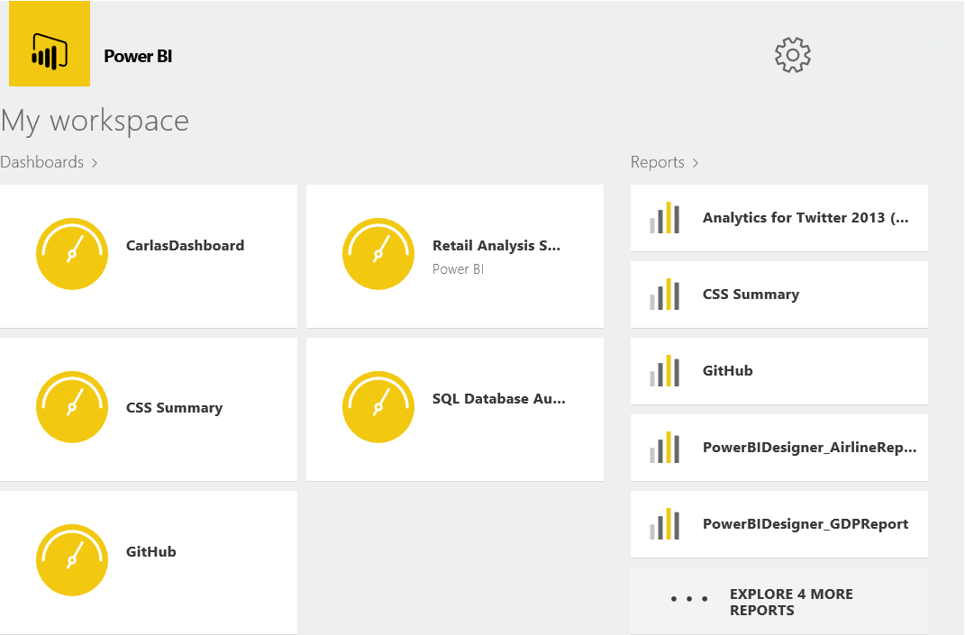

Power BI for Windows App

For more information, see [Power BI apps for mobile devices](https://support.powerbi.com/knowledgebase/articles/652525) (https://support.powerbi.com/knowledgebase/articles/652525).

* **Groups**: Groups in Power BI bring you and your colleagues together to collaborate, communicate, and connect with your data across Office 365. Create a group in either Power BI or Office 365. Then invite co-workers into this group workspace where you can collaborate on your organization’s shared dashboards, reports, and datasets. For more information, see [Groups in Power BI](https://support.powerbi.com/knowledgebase/articles/654247) (https://support.powerbi.com/knowledgebase/articles/654247).
* **Data Catalog**: You can share information about a query in the Power BI Data Catalog with all users or a specific set of users within the organization. Shared queries appear in search results when users perform an online search in Power Query. This enables the users to easily discover and reuse the shared queries and their underlying data for their data analysis and reporting. For more information, see [Share queries in the Power BI Data Catalog](https://support.office.com/en-us/article/Share-queries-in-the-Power-BI-Data-Catalog-353B6B69-47F8-422E-BF7E-DB70BCA51EEA?ui=en-US&rs=en-US&ad=US) (https://support.office.com/en-us/article/Share-queries-in-the-Power-BI-Data-Catalog-353B6B69-47F8-422E-BF7E-DB70BCA51EEA?ui=en-US&rs=en-US&ad=US).
* **Excel Workbooks**: You can bring any Excel workbook (XLSX or XLSM) into Power BI and explore the whole file, exactly as you would in Excel Online. To view and explore whole Excel files in Power BI, your workbooks need to be on OneDrive for Business. Any changes you make to a file on OneDrive appear automatically in the file in Power BI. For more information, see [Bring whole Excel files in to Power BI](https://support.powerbi.com/knowledgebase/articles/640168) (https://support.powerbi.com/knowledgebase/articles/640168).

For more information about Power BI, see [Power BI – basic concepts](https://support.powerbi.com/knowledgebase/articles/487029-power-bi-basic-concepts) (https://support.powerbi.com/knowledgebase/articles/487029-power-bi-basic-concepts) and [Get started with Power BI](https://support.powerbi.com/knowledgebase/articles/430814-get-started-with-power-bi) (https://support.powerbi.com/knowledgebase/articles/430814-get-started-with-power-bi).

### Power BI Desktop

Power BI Desktop lets you create a collection of queries, data connections, and reports that can easily be shared with others. Power BI Desktop integrates proven Microsoft technologies – the powerful Query engine, data modeling, and visualizations – and works seamlessly with the online Power BI service.

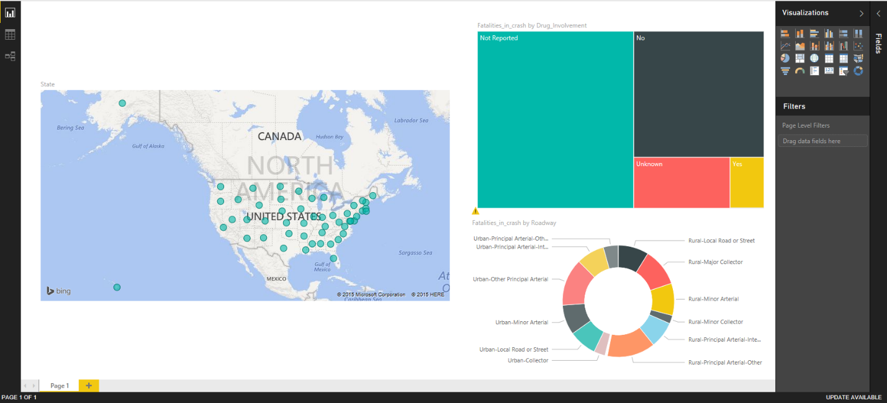

You use the **Get Data** command on the ribbon to connect to a variety of data sources such as Excel, SQL Server, an OData Feed, or Azure SQL Database. There are many more data sources to choose from.

For more information, see [Getting Started with Power BI Desktop](http://support.powerbi.com/knowledgebase/articles/471664-getting-started-with-power-bi-designer) (http://support.powerbi.com/knowledgebase/articles/471664-getting-started-with-power-bi-designer)

### Power BI

With the Power BI you can bring together in one place dashboards that help you track the pulse of your business or organization, drill down to report details, and connect multiple datasets from a variety of data sources. You can share your dashboards with people in your organization.

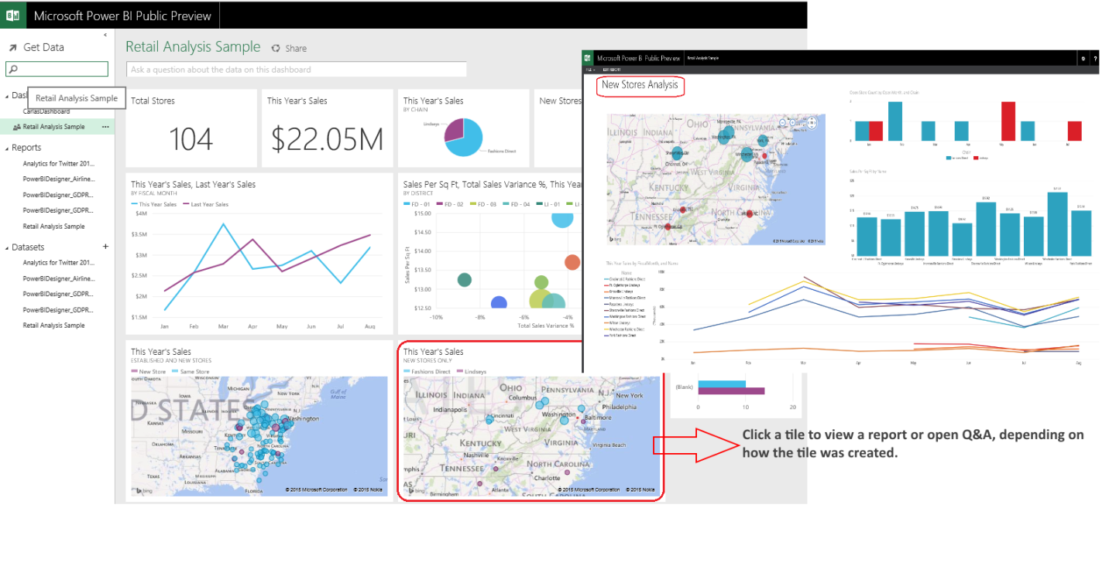

Power BI Dashboard

For more information, see [Get started with Power BI](http://support.powerbi.com/knowledgebase/articles/430814-get-started-with-power-bi-preview) (<http://support.powerbi.com/knowledgebase/articles/430814-get-started-with-power-bi-preview>).

For advice on creating dashboards, see [Tips for designing a great Power BI dashboard](http://support.powerbi.com/knowledgebase/articles/433616-tips-for-designing-a-great-dashboard) (http://support.powerbi.com/knowledgebase/articles/433616-tips-for-designing-a-great-dashboard).

### Data Mining Client for Excel

The Data Mining Client for Excel is a set of tools that let you perform common data mining tasks, from data cleansing to model building and prediction queries. You can use data in Excel tables or ranges, or access external data sources.

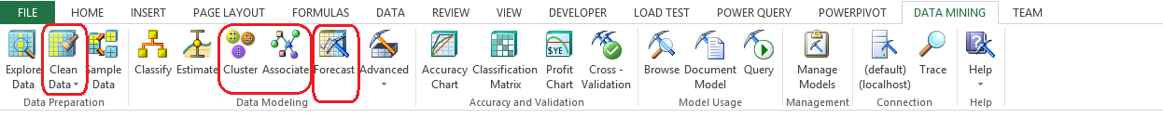

Figure – Data Mining Ribbon in Excel

The Data Mining Client includes the following features.

* Load your data into Excel, cleanse the data, check for outliers, and create statistical summaries. You can also perform different kinds of sampling, profile the data, and test models using external data. The Data Mining Client is the easiest way to prepare data for analysis without complex scripts or ETL processes.
* Use wizard interfaces to access well-known, empirically tested data mining algorithms, including clustering (K-means and EM), association analysis, time series analysis, and decision trees. Advanced modeling options for each wizard let you choose different algorithms, such as the Naïve Bayes or neural networks, and customize behavior such as the cluster seed or initial sampling size.

All data mining algorithms are hosted in an instance of Analysis Services, giving you more power to build complex models.

* Use industry-standard tools for testing models, including lift charts and cross-validation. The wizards provided enable you to test the validity of the data set and its accuracy. The query wizard builds queries to use the models for prediction and scoring.
* Charts generated by most tools can be saved directly to Excel. Use the Browsing Models in Excel (SQL Server Data Mining Add-ins) tool to explore the models.
* Save your data mining model to the server, to use in further testing, or to deploy to a production server for greater scalability. The Data Mining Client for Excel maintains an active connection to the server.

For more information, see [Data Mining Client for Excel (SQL Server Data Mining Add-ins)](https://msdn.microsoft.com/en-us/library/dn282385(v=sql.130).aspx) ([https://msdn.microsoft.com/en-us/library/dn282385(v=sql.130).aspx)](http://msdn.microsoft.com/en-us/library/dn282385(v=sql.120).aspx)).

For help with installation, see this page on the Download Center: <http://www.microsoft.com/en-us/download/details.aspx?id=35578> .

## Typical Infrastructure

Infrastructure requirements for self-service BI are minimal, and you can generally develop and share reports and information with little to no IT support, although IT infrastructure is a helpful mechanism for report distribution and collaboration. Implementations of SharePoint Server with Excel Services or Power Pivot for SharePoint enabled, allow more efficient management and distribution of the self-service analysis solutions.

# Corporate BI

Corporate BI involves creating highly formatted and distributable reports. Examples of these reports include sales order detail reports, inventory-on-hand reports, or sales attainment reports. Some key characteristics are:

* Data used to create reports comes from corporate sanctioned and IT managed data sources.
* Reports are highly formatted and frequently printed.
* Reports may be complex and require special technical skills such as advanced SQL, MDX, or other query languages to build.
* Reports are often created with one or more user selectable parameters, but are not capable of extensive interactivity.
* Reports are usually authored by IT or BI developers, often because the complexity of the reports exceeds the capabilities of the user base for self-service reporting.
* The reports are refreshed on a regular basis and available on-demand.
* Reports may be delivered in multiple formats such as PDF, Excel, HTML, and so on.
* Reports may be shared broadly across the organization.

## Tool Options

The following tools support corporate BI.

* SQL Server Analysis Services
* SQL Server Reporting Services
* Power View for SharePoint 2013
* SharePoint 2013 Dashboards
* PerformancePoint Services

### Microsoft SQL Server Analysis Services

The basis of any Analysis Services solution is a business intelligence semantic data model and a server instance that instantiates, processes, queries, and manages objects in that model.

Models are built on historical data that you are already collecting in transactional databases and other data stores, and then annotated with metadata that lets you measure, manipulate, and compare business data in ad hoc queries or custom reports. After a model is designed, it is deployed to an Analysis Services server as a database, where it becomes available to authorized users who connect to it through Excel and other tools.

#### SQL Server 2016 Analysis Services

In SQL Server 2016, many new DAX functions have been added, such as date and time functions, filter functions, and math and trig functions.

A graphical user interface has been added to SQL Server Management Studio to configure and manage Analysis Services Extended Events.

There is a new 1200 compatibility level for tabular models, introducing the first wave of new functionality planned for tabular solutions in SQL Server 2016.

SQL Server Data Tools (SSDT) for Visual Studio 2015 now includes project templates for Analysis Services solutions, including Analysis Services Tabular Projects used for building models at the 1200 compatibility level.

For more information about Analysis Services, see [Analysis Services](https://msdn.microsoft.com/en-us/library/bb522607.aspx) ([https://msdn.microsoft.com/en-us/library/bb522607.aspx)](http://msdn.microsoft.com/en-us/library/bb522607(v=sql.120).aspx)) and [What’s New in Analysis Services](https://msdn.microsoft.com/en-US/library/bb522628.aspx) (https://msdn.microsoft.com/en-US/library/bb522628.aspx).

### Microsoft SQL Server Reporting Services

Microsoft SQL Server Reporting Services enables IT to create and manage both static and parameterized reports and provides a platform for delivering information throughout the organization.

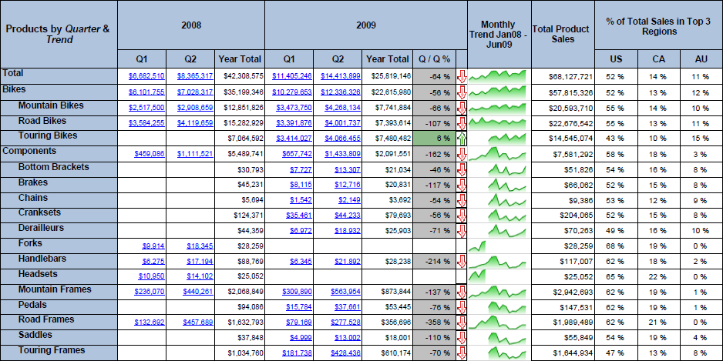

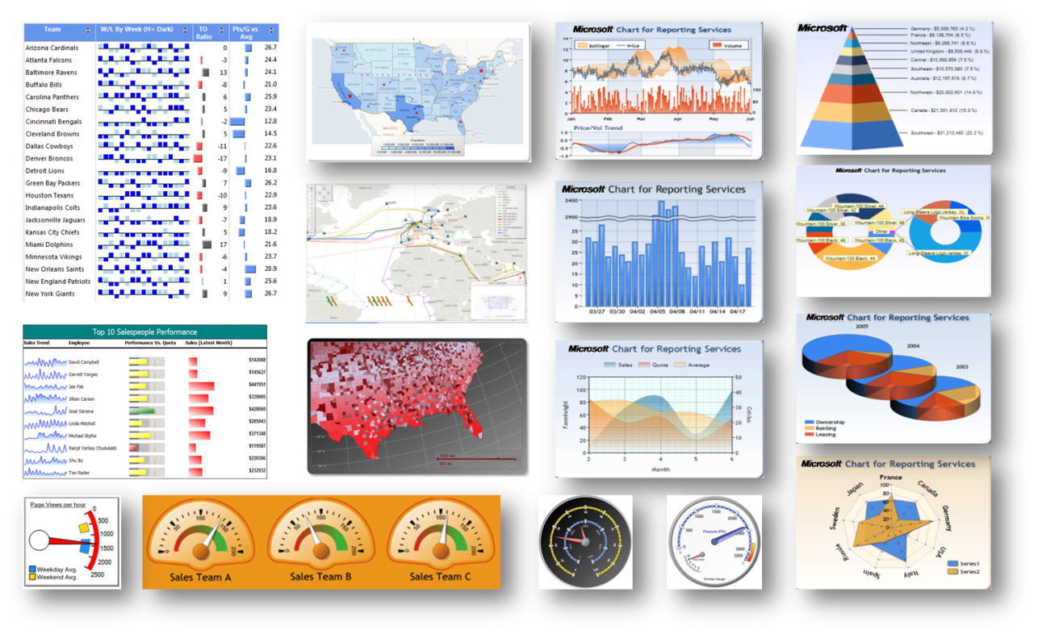

Advanced Data Visualization

When the report is accessed via a portal, you can interact and perform analysis through the use of parameters and filters embedded in the reports. With the use of parameters, drill-down, and drill-through capabilities, you are able to perform more guided reporting and analysis. Additionally, reports can be linked together to allow for more in-depth analysis via drill-through capabilities.

The report distribution components of Reporting Services allow reports to be scheduled and distributed using different delivery mechanisms and in different generation formats. The reports may be delivered via portal, file share, email, or sent directly to a printer, and may be generated as PDF, Excel, XML, comma delimited text file, TIFF image, HTML or Microsoft Word formats.

Enhancements to subscriptions in SQL Server 2016 include the ability to quickly disable and enable subscriptions, quickly change the owner of a subscription, and support for shared credential for file share subscriptions.

In SQL Server 2016, a new HTML5 rendering engine targets modern web "full" standards mode and modern browsers. The new rendering engine no longer relies on quirks mode used by a few older browsers. In addition, you can now export reports in the PPTX format from Report Builder, Report Designer (in SSDT), Report Manager.

Support for Power BI is new in SQL Server 2016. You can pin Reporting Services report items from the report viewer toolbar to a Power BI dashboard as a new tile. For more information, see [Pin Reporting Service items to Power BI Dashboards](https://msdn.microsoft.com/en-US/library/mt604784.aspx) (https://msdn.microsoft.com/en-US/library/mt604784.aspx).

You create Reporting Services reports using Report Builder and Report Designer in SQL Server Data Tools.

#### Report Builder

Report Builder provides a full-featured reporting environment that allows you to develop highly formatted reports using an Excel-like ribbon. Report Builder provides formatting and pagination features, and advanced visualization options such as geospatial mapping, sparklines, and gauges.

In SQL Server 2016, you can enhance your reports with Tree Map and Sunburst charts, great ways to display hierarchal data.

|  |  |
| --- | --- |
| Tree Map Chart | Sunburst Chart |

You can also customize the parameters pane in SQL Server 2016. Using the design surface in Report Builder, you can drag a parameter to a specific column and row in the parameters pane. You can add and remove columns to change the layout of the pane.

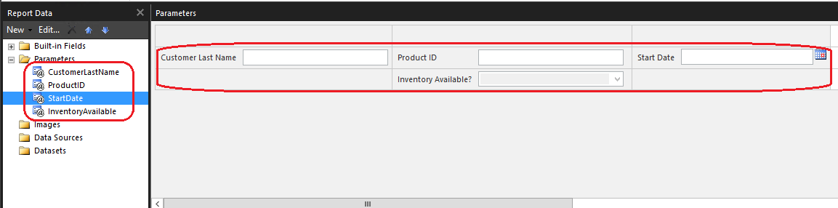

Although you don’t necessarily need to know how to write SQL queries to author reports with Report Builder, it does typically require a more sophisticated skill set then Excel or PowerPivot does.

#### SSDT

SSDT is a Microsoft Visual Studio environment with enhancements that are specific to business intelligence solutions. For SQL Server 2016, SSDT is a separate download. For more information, see [Download Latest SQL Server Data Tools](https://msdn.microsoft.com/en-US/library/mt204009.aspx) (<https://msdn.microsoft.com/en-US/library/mt204009.aspx>).

For information about versions of SSDT for previous releases of SQL Server, see [SQL Server Data Tools and SQL Server Business Intelligence (SSDT-BI)](http://curah.microsoft.com/30004/sql-server-data-tools-ssdt-and-sql-server-business-intelligence) (http://curah.microsoft.com/30004/sql-server-data-tools-ssdt-and-sql-server-business-intelligence).

You can use SSDT to create and manage solutions and projects for Reporting Services reports and report-related items. It provides the Report Designer authoring environment. In Report Designer, you can open, modify, preview, save, and deploy report definitions, shared data sources, shared datasets, and report parts.

When you install Reporting Services, the following project templates are made available in SSDT:

* **Report Server Project**. A Report Server Project is a Business Intelligence Projects template installed by Visual Studio. Report Server project properties apply to all reports and all shared data sources in the project. These properties include the URL for the report server and the folder names for reports and shared data sources.
* **Report Server Project Wizard**. In the wizard, you can create a report by creating a connection string to a data source, setting data source credentials, designing a query, adding a table or matrix data region, specifying report data and groups, picking a font and color style, publishing the report to a report server, and previewing the report locally. After you create a report with the wizard, you can change the report data and the report designer by using Report Designer in the Report Server project.

For more information about Reporting Services, see the following articles.

[Reporting Services in SQL Server Data Tools (SSDT)](https://technet.microsoft.com/en-us/library/ms173745(v=sql.130).aspx) ([https://technet.microsoft.com/en-us/library/ms173745(v=sql.130).aspx)](http://technet.microsoft.com/en-us/library/ms173745(v=sql.120).aspx))

[Reporting Services (SSRS)](https://msdn.microsoft.com/en-us/library/ms159106(v=sql.130).aspx) ([https://msdn.microsoft.com/en-us/library/ms159106(v=sql.130).aspx)](http://msdn.microsoft.com/en-us/library/ms159106(v=sql.120).aspx)).

[What’s New in Reporting Services](https://technet.microsoft.com/en-US/library/ms170438.aspx) (https://technet.microsoft.com/en-US/library/ms170438.aspx)

### Power View for SharePoint 2013

Power View is a browser-based application launched from SharePoint Server 2013 that enables you to present and share insights with others in their organization through interactive presentations.

You can create a single report with multiple views. All the views in one report are based on the same Data Model. You can copy and paste from one view to another, and duplicate whole views. If you save preview images of the views, an image of each view is displayed in the Power Pivot Gallery in SharePoint Server 2013. Creating, opening, and saving Power View reports (RDLX files) all take place in SharePoint Server.

Power View is part of the Microsoft SQL Server 2014 Reporting Services add-in for Microsoft SharePoint Server 2010 and 2013 Enterprise Editions, as well as a feature of Microsoft Excel 2013.

Power View reports in SharePoint Server are RDLX files. Power View sheets in Excel are part of the Excel XLSX workbook. You can’t open a Power View RDLX file in Excel, or open an Excel XLSX file with Power View sheets in Power View in SharePoint. You also can’t copy charts or other visualizations from the RDLX file into the Excel workbook.

You can save Excel XLSX files with Power View sheets to SharePoint Server, either on premises or in Office 365, and open those files in SharePoint. Read more about Power View in Excel in SharePoint Server 2013 or in SharePoint Online in Office 365.

Both Power View in SharePoint Server and Power View in Excel need Silverlight installed on the machine.

For information about what’s new in Power View in SharePoint Server, see [What’s new in Power View in Excel 2013 and in SharePoint Server](http://office.microsoft.com/en-us/excel-help/whats-new-in-power-view-in-excel-2013-and-in-sharepoint-server-HA102901475.aspx?CTT=5&origin=HA102835634#_Toc358038111) (<http://office.microsoft.com/en-us/excel-help/whats-new-in-power-view-in-excel-2013-and-in-sharepoint-server-HA102901475.aspx?CTT=5&origin=HA102835634#_Toc358038111>).

For additional information about Power View in SharePoint 2013, see the following articles.

* [System requirements for Power View in SharePoint](http://office.microsoft.com/en-us/excel-help/system-requirements-for-power-view-HA102835724.aspx?CTT=5&origin=HA102835634) (<http://office.microsoft.com/en-us/excel-help/system-requirements-for-power-view-HA102835724.aspx>)
* [Power View in SharePoint Server: Create, save, and print reports](http://office.microsoft.com/en-us/excel-help/power-view-in-sharepoint-server-create-save-and-print-reports-HA102834736.aspx?CTT=5&origin=HA102835634) (<http://office.microsoft.com/en-us/excel-help/power-view-in-sharepoint-server-create-save-and-print-reports-HA102834736.aspx>)
* [Keyboard shortcuts and accessibility in Power View in SharePoint](http://office.microsoft.com/en-us/excel-help/keyboard-shortcuts-and-accessibility-in-power-view-in-excel-HA102834863.aspx?CTT=5&origin=HA102835634) (<http://office.microsoft.com/en-us/excel-help/keyboard-shortcuts-and-accessibility-in-power-view-in-excel-HA102834863.aspx>)
* [Reports with multiple views in Power View in SharePoint](http://office.microsoft.com/en-us/excel-help/reports-with-multiple-views-in-power-view-in-sharepoint-HA102835711.aspx?CTT=5&origin=HA102835634) (<http://office.microsoft.com/en-us/excel-help/reports-with-multiple-views-in-power-view-in-sharepoint-HA102835711.aspx>)
* [Understanding Multidimensional Model Objects in Power View](http://office.microsoft.com/en-us/excel-help/understanding-multidimensional-model-objects-in-power-view-HA104018589.aspx?CTT=5&origin=HA102835634) (<http://office.microsoft.com/en-us/excel-help/understanding-multidimensional-model-objects-in-power-view-HA104018589.aspx>)
* [Power View: Explore, visualize, and present your data](http://office.microsoft.com/en-us/excel-help/power-view-explore-visualize-and-present-your-data-HA102835634.aspx) (<http://office.microsoft.com/en-us/excel-help/power-view-explore-visualize-and-present-your-data-HA102835634.aspx>)

For information about SharePoint Server 2016 IT Preview, see [Explore SharePoint Server 2016 IT Preview](https://technet.microsoft.com/EN-US/library/cc261970(v=office.16).aspx) (https://technet.microsoft.com/EN-US/library/cc261970(v=office.16).aspx).

### SharePoint 2013 Dashboards

A SharePoint dashboard is a related group of interactive scorecard and report views that are organized together in a SharePoint or Web-hosted site. SharePoint Server 2013 enables you to create and use dashboards that provide up-to-date information in a centrally managed, easily accessed location. You can use SharePoint Server tools to create and use dashboards that are suitable for an individual, team, group, or the entire organization.

A dashboard report helps business decision makers understand the current health of their business. A dashboard often combines key performance indicators from various business functions on a single page to help provide an at-a-glance view of performance and the ability to drill down further when something is off track or performing extremely well. The following are key characteristics of performance monitoring dashboards.

* Provides an at-a-glance view of business performance.
* Provides a more holistic view of the business or business function by combining multiple types of content together.
* Data in multiple formats are combined on one page. Some examples might include a tabular report with spark-lines, along with trended graphs or bar charts, and geospatial maps or scorecards.
* Enables drill down to perform root cause analysis for data anomalies.
* A corporate data platform is in place and includes an OLAP component, all being refreshed regularly.
* Often deployed broadly across the organization and various levels in the organization.

If you want to create a simple dashboard for an individual or a small group, you might want to create a Web Part page and add status indicators and a Chart Web Part to it. For more information, see the following articles.

* [Create SharePoint site pages](http://office.microsoft.com/en-us/sharepoint-designer-help/create-sharepoint-site-pages-HA101782505.aspx) (http://office.microsoft.com/en-us/sharepoint-designer-help/create-sharepoint-site-pages-HA101782505.aspx)
* [Create a chart by using the Chart Web Part](http://office.microsoft.com/en-us/sharepoint-server-help/create-a-chart-by-using-the-chart-web-part-HA101889211.aspx?CTT=5&origin=HA010380601) (http://office.microsoft.com/en-us/sharepoint-server-help/create-a-chart-by-using-the-chart-web-part-HA101889211.aspx)
* [Getting started with SharePoint status indicators](http://office.microsoft.com/en-us/sharepoint-server-help/getting-started-with-sharepoint-status-indicators-HA010380634.aspx?CTT=5&origin=HA010380601) (<http://office.microsoft.com/en-us/sharepoint-server-help/getting-started-with-sharepoint-status-indicators-HA010380634.aspx>)

### PerformancePoint Services

The PerformancePoint Services component of Microsoft SharePoint Server 2013 is a performance management service that is used to create dashboards and scorecards.

PerformancePoint Services provides the ability to pull multiple view types into a single dashboard. In a PerformancePoint Services dashboard, you can interact with SSRS reports, cube-based graphs, performance maps, decomposition trees and Visio diagrams. Other content types can even be integrated by displaying any web page desired within a frame of the dashboard.

Dashboard filters can be applied across the dashboard components, allowing you to update multiple or all parts of a dashboard simultaneously. With cube-based graphs and charts, you can perform ad-hoc analysis, slice and dice dimensional data, navigate through hierarchies, and pivot and change chart types. Dashboards can incorporate data from a variety of sources, providing the capability to develop and manage the presentation of reports through one tool.

PerformancePoint Services provides a platform for designing and building both balanced and free-form scorecards. The balanced scorecards focus the organization on finding a balanced set of metrics across multiple perspectives – balancing the typical lagging financial indicators with a broader set of leading indicators that better predict future performance. Balanced and Free-form scorecards along with Strategy Maps allow organizations to provide a concise vehicle for communicating overall company performance against well-defined targets. A major benefit of scorecards is the ability to aggregate and display non-like data into unified and summarized scores.

PerformancePoint Services allows companies to set up hierarchical KPIs with relative weightings that align with perspectives and objectives. Targets can be defined at each intersection and ranges can be set for defining Red/Yellow/Green status thresholds for each KPI. Scorecards can also be pivoted and filtered by a number of dimensions, allowing you to perform root cause analysis on KPIs that are not meeting the targets. Scorecards are often displayed as a component within in a Dashboard and interact with other reports in the dashboard.

Because PerformancePoint Services is a part of SharePoint Server 2013, the Scorecards are easily shared and distributed

For more information, see the following articles.

* [PerformancePoint Services in SharePoint Server 2013 overview](http://technet.microsoft.com/en-us/library/ee424392.aspx) (<http://technet.microsoft.com/en-us/library/ee424392.aspx>)
* [Overview of PerformancePoint KPI Details reports](http://technet.microsoft.com/en-us/library/gg482033.aspx) (<http://technet.microsoft.com/en-us/library/gg482033.aspx>)
* [Overview of PerformancePoint scorecards](http://technet.microsoft.com/en-us/library/gg410938.aspx) (http://technet.microsoft.com/en-us/library/gg410938.aspx)

## Typical Infrastructure

For corporate BI, a data warehouse, data mart and/or online-analytical-processing (OLAP) environment is often in place and used as the data source. The existence of OLAP cubes forms the foundation of BI analysis in these environments. Data is typically refreshed regularly on schedule to provide the most current information possible. For these reasons, an IT department is needed to support the infrastructure for BI.

The IT department is in charge of creating and managing the corporate data sources. The IT department should be experienced dealing with BI structures and reporting technologies, and will be heavily involved in report development and management including having a firm understanding of how to use the reporting tools and query languages such as SQL and MDX.

# BI and Microsoft Azure Technologies

The Azure Machine Learning, Azure Stream Analytics, and the Cortana Analytics Suite are enabling technologies for business intelligence.

## Azure Machine Learning

With Microsoft Azure Machine Learning Studio, you can build, test, and deploy predictive analytics solutions that operate on your data. The Machine Learning service and development environment is cloud-based, providing compute resource and memory flexibility.

In Machine Learning Studio, you drag-and-drop datasets and analysis modules onto a canvas, connect them together to create an experiment, and then run the experiment. You can edit the experiment and re-run it, enabling you to iterate on your model design. Programming is not required, but if you need to extend your experiment with custom code you can use both R and Python. More languages will be supported in the future. You can also publish your experiment, or part of the experiment, as a web service that can be consumed by applications and BI tools.

An experiment typically includes data that you have either uploaded to your workspace or loaded from a cloud data source such as Azure storage or URLs. And, the experiment includes an analytical module that processes or analyzes data.

In Azure Machine Learning, you work with data in the form of datasets, which are tables of data with accompanying metadata that describes the schema and analytical usage of each column. The modules provide many tools that are important and useful in data science, including a variety of leading-edge machine learning algorithms. Other modules provide data entry functions, tools for transforming data for statistical analysis, and support for machine learning workflows such as training, scoring, and validation processes.

The following image shows a typical experiment with multiple modules. One module is used to choose a subset of columns ([Project Columns](https://msdn.microsoft.com/library/azure/1ec722fa-b623-4e26-a44e-a50c6d726223/)), another creates a linear regression model to predict a numeric outcome ([Linear Regression](https://msdn.microsoft.com/library/azure/31960a6f-789b-4cf7-88d6-2e1152c0bd1a/)), and successive modules train the model ([Train Model](https://msdn.microsoft.com/library/azure/5cc7053e-aa30-450d-96c0-dae4be720977/)) and generate predictions using a trained regression or classification model ([Score Model](https://msdn.microsoft.com/library/azure/401b4f92-e724-4d5a-be81-d5b0ff9bdb33/)).

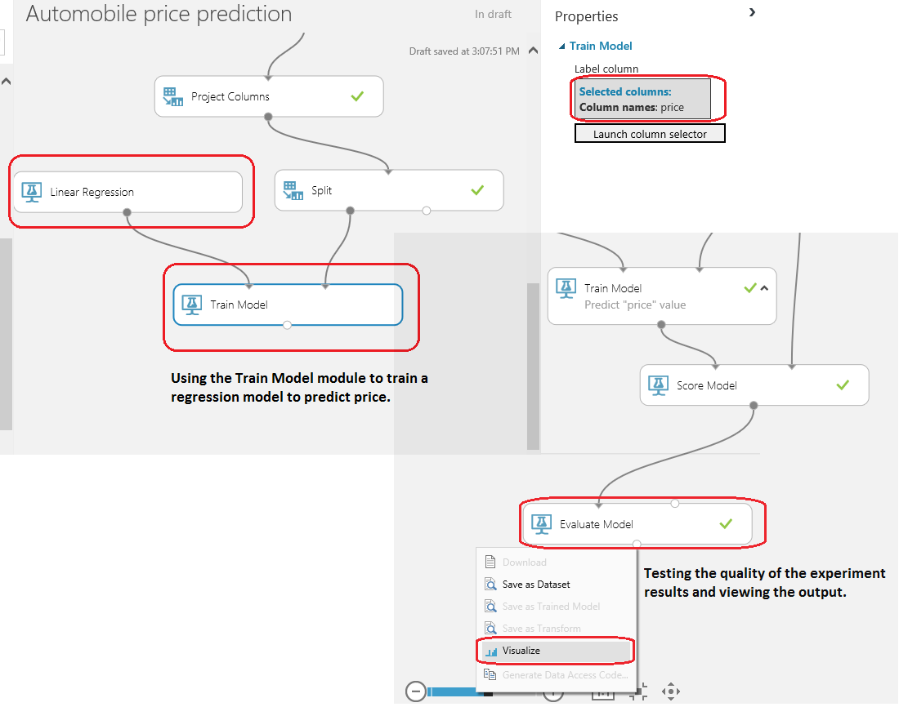

Image based on “[Create your first experiment in Azure Machine Learning Studio](http://azure.microsoft.com/en-us/documentation/articles/machine-learning-create-experiment/)” article

For more information about Microsoft Azure Learning, see these articles.

* [Microsoft Azure Machine Learning](http://azure.microsoft.com/en-us/services/machine-learning/?WT.mc_id=azurebg_US_sem_bing_BR_BRMachineLearningSolution_Nontest_MachineLearning_azureml&WT.srch=1) (http://azure.microsoft.com/en-us/services/machine-learning/?WT.mc_id=azurebg_US_sem_bing_BR_BRMachineLearningSolution_Nontest_MachineLearning_azureml&WT.srch=1)
* [What is Azure Machine Learning Studio?](http://azure.microsoft.com/en-us/documentation/articles/machine-learning-what-is-ml-studio/) (<http://azure.microsoft.com/en-us/documentation/articles/machine-learning-what-is-ml-studio/>)
* [Develop a predictive solution for credit risk assessment in Azure Machine Learning](http://azure.microsoft.com/en-us/documentation/articles/machine-learning-walkthrough-develop-predictive-solution/) (http://azure.microsoft.com/en-us/documentation/articles/machine-learning-walkthrough-develop-predictive-solution/)

For tutorials, templates, and pre-developed solutions and walkthroughs for a variety of scenarios, see the following.

* Azure Machine Learning Studio includes many sample datasets that have been pre-configured to make analysis easier.
* [Create your first experiment in Azure Machine Learning Studio](Create%20your%20first%20experiment%20in%20Azure%20Machine%20Learning%20Studio) (<http://azure.microsoft.com/en-us/documentation/articles/machine-learning-create-experiment/>)

## Azure Stream Analytics

Azure Stream Analytics provides complex event processing over streaming data in the cloud. The processing is low-latency, highly available with built-in recovery and checkpointing capabilities, and scalable. You can combine streams of data with historic records or reference data to derive business insights.

The key scenarios are:

* Perform complex event processing on high-volume and high-velocity data
* Collect event data from globally distributed assets or equipment, such as connected cars or utility grids
* Process telemetry data for near real-time monitoring and diagnostics
* Capture and archive real-time events for future processing

Building a stream-processing system is easy with Azure Stream Analytics. In the Azure portal, you author a streaming job by using a language similar to the familiar SQL language to specify transformations and analyze the data. You don’t have to write complex, custom code. Using the SQL-like Stream Analytics query language operators, you can define time-based windowed operations, correlate multiple streams to detect patterns, or even compare current conditions to historic values and models.

The following image shows the dashboard for a Stream Analytics job. A query is run against a stream of call data (input). This image is based on the tutorial, [Get started using Azure Stream Analytics: Real-time fraud detection](http://azure.microsoft.com/en-us/documentation/articles/stream-analytics-get-started/#create-a-stream-analytics-job).

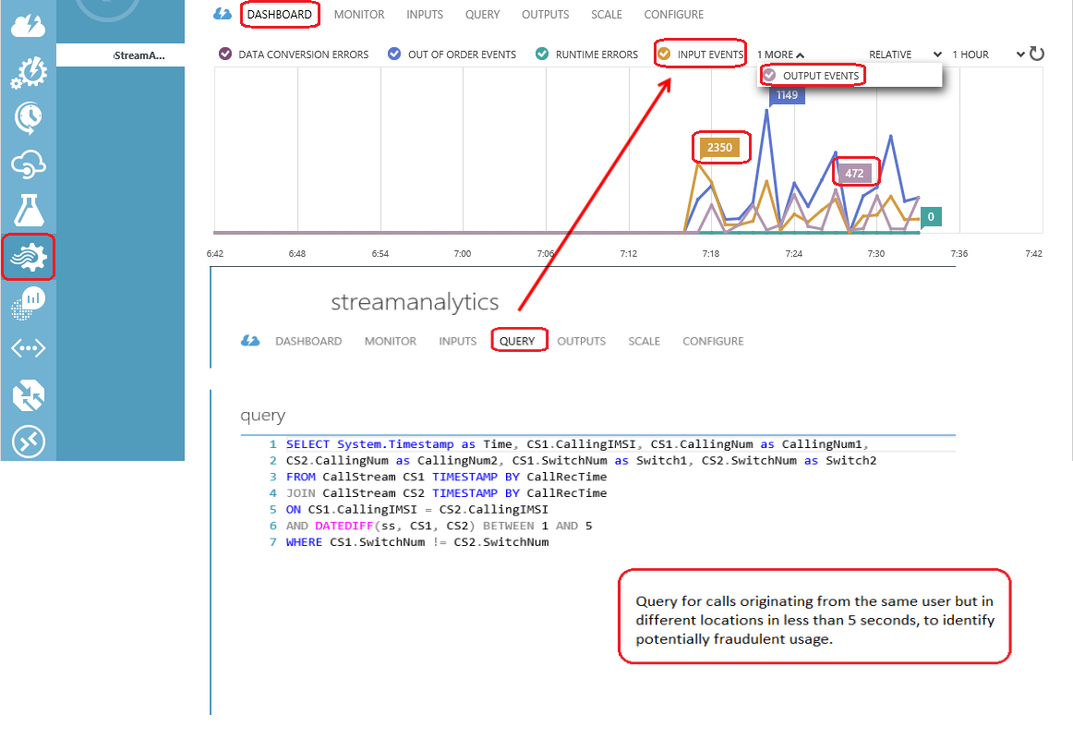

The service can easily scale from a few kilobytes to a gigabyte or more of events processed per second. The configurability of Stream Analytics enables you to determine how much compute power to each step of the pipeline to achieve the desired peak throughput.

Connection support includes connecting Stream Analytics directly to Azure Event Hubs, and to the Azure Blob service for historical data. With Azure Event Hubs, you can then integrate Stream Analytics with other data sources and processing engines. The results of the Stream Analytics job can be outputted to a number of targets, including but not limited to Azure Blog Storage, Azure Table Storage, and Azure SQL Database.

For more information about Azure Stream Analytics, see these articles.

* [What is Azure Stream Analytics?](http://azure.microsoft.com/en-us/documentation/articles/stream-analytics-introduction/) (<http://azure.microsoft.com/en-us/documentation/articles/stream-analytics-introduction/>)
* [Get started using Azure Stream Analytics: Real-time fraud detection](http://azure.microsoft.com/en-us/documentation/articles/stream-analytics-get-started/#create-a-stream-analytics-job) (<http://azure.microsoft.com/en-us/documentation/articles/stream-analytics-get-started/#create-a-stream-analytics-job>)
* [Azure Stream Analytics & Power BI: Live Dashboard on Real time Analytics of Streaming Data](http://azure.microsoft.com/en-us/documentation/articles/stream-analytics-power-bi-dashboard/) (http://azure.microsoft.com/en-us/documentation/articles/stream-analytics-power-bi-dashboard/)

## Cortana Analytics Suite

Cortana Analytics Suite is a fully managed big data and advanced analytics suite that enables you to transform your data into intelligent action. Join this session and learn about the suite, see end-to-end scenario demos, and hear customer success stories.

For more information, see the following site and documentation.

* [Getting Started Cortana Analytics Suite](https://azure.microsoft.com/en-us/documentation/videos/azurecon-2015-introducing-the-cortana-analytics-suite/) (video) (<https://azure.microsoft.com/en-us/documentation/videos/azurecon-2015-introducing-the-cortana-analytics-suite/>)
* [What is the Cortana Analytics Process (CAP)?](https://azure.microsoft.com/en-us/documentation/articles/machine-learning-data-science-the-cortana-analytics-process/) (<https://azure.microsoft.com/en-us/documentation/articles/machine-learning-data-science-the-cortana-analytics-process/>)
* [Share and discover solutions in the Cortana Analytics Gallery](https://azure.microsoft.com/en-us/documentation/articles/machine-learning-gallery-how-to-use-contribute-publish/) (<https://azure.microsoft.com/en-us/documentation/articles/machine-learning-gallery-how-to-use-contribute-publish/>)
* [Why Cortana Analytics](http://www.microsoft.com/en-us/server-cloud/cortana-analytics-suite/why-cortana-analytics.aspx) (http://www.microsoft.com/en-us/server-cloud/cortana-analytics-suite/why-cortana-analytics.aspx)

# Advanced Analytics

Advanced analytics involves tools and techniques that are used to forecast future outcomes and behaviors. Data mining and predictive analytics are some of the analytical categories that are part of advanced analytics.

## Tool Options

The following tools support advanced analytics.

* Data Mining Client for Excel
* Data Mining in Analysis Services

### Data Mining Client for Excel

The Data Mining Client for Excel enables you to create, test, explore, and manage data mining models within Excel using either your spreadsheet data or external data accessible through your SQL Server Analysis Services instance.

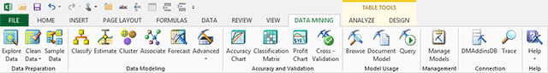

Figure – Data Mining Ribbon in Excel

You can perform common data mining tasks, from data cleansing to model building and prediction queries. The options on the Data Modeling section of the toolbar let you derive patterns from data; group rows of data based on attributes, or explore associations. Use the wizards on the Accuracy and Validation toolbar to use industry-standard tests for validating the accuracy of your models, and for assessing the viability of the data set for creating models. Models you create are automatically opened for browsing. However, you can also browse models on the server and generate new visualizations. Use the [Visio shapes](http://msdn.microsoft.com/en-us/library/dn282340(v=sql.120).aspx) to export model diagrams to a customizable canvas.

For more information, see [Data Mining Client for Excel (SQL Server Data Mining Add-ins)](https://msdn.microsoft.com/en-us/library/dn282385(v=sql.130).aspx) (https://msdn.microsoft.com/en-us/library/dn282385(v=sql.130).aspx).

### Data Mining in Analysis Services

SQL Server Analysis Services provides an integrated platform for solutions that incorporate data mining. You can use either relational or cube data to create business intelligence solutions with predictive analytics.

Data mining in Analysis Services uses well-researched statistical principles to discover patterns in your data, helping you make intelligent decisions about complex problems. By applying the data mining algorithms in Analysis Services to your data, you can forecast trends, identify patterns, create rules and recommendations, analyze the sequence of events in complex data sets, and gain new insights.

In SQL Server, data mining is powerful, accessible, and integrated with the tools that many people prefer to use for analysis and reporting.

For more information, see [Data Mining (SSAS)](https://technet.microsoft.com/en-us/library/bb510516(v=sql.130).aspx) ([https://technet.microsoft.com/en-us/library/bb510516(v=sql.130).aspx)](http://technet.microsoft.com/en-us/library/bb510516(v=sql.120).aspx)) and [Data Mining Concepts](https://technet.microsoft.com/en-us/library/ms174949(v=sql.130).aspx) (https://technet.microsoft.com/en-us/library/ms174949(v=sql.130).aspx).

# Conclusion

Microsoft provides a variety of Business Intelligence (BI) tools that can address key (BI) workloads. This article discussed the workloads and the tools that best support each workload. The intent was to assist you with choosing the BI tools that meet your organization’s information needs.

**For more information:**

[Compare Business Intelligence Capabilities In Different Microsoft Environments](https://msdn.microsoft.com/en-us/library/dn877942(v=sql.120).aspx) (https://msdn.microsoft.com/en-us/library/dn877942(v=sql.120).aspx)

[Office 365 for administrators](http://technet.microsoft.com/en-us/library/dn127064(v=office.14).aspx) (<http://technet.microsoft.com/en-us/library/dn127064(v=office.14).aspx)>

[SharePoint 2013](http://technet.microsoft.com/en-us/library/cc303422.aspx) (<http://technet.microsoft.com/en-us/library/cc303422.aspx>)

[Microsoft Power BI Videos](https://support.powerbi.com/knowledgebase/articles/475702-power-bi-videos) (https://support.powerbi.com/knowledgebase/articles/475702-power-bi-videos)

[Books Online for SQL Server 2016](https://technet.microsoft.com/en-us/library/ms130214(v=sql.130).aspx) ([https://technet.microsoft.com/en-us/library/ms130214(v=sql.130).aspx)](http://technet.microsoft.com/en-us/library/ms130214(v=sql.120).aspx))

[Install SQL Server 2016 Business Intelligence Features](https://technet.microsoft.com/en-us/library/hh231681(v=sql.130).aspx) (<http://technet.microsoft.com/en-us/library/hh231681(v=sql.120).aspx)>

Did this paper help you? Please [send feedback](mailto:sqlPaperFB@microsoft.com?subject=White%20Paper%20Feedback:%20[Introducing%20Microsoft%20Business%20Intelligence%20(BI)%20Tools]).

Tell us on a scale of 1 (poor) to 5 (excellent), how would you rate this paper and why have you given it this rating? For example:

* Are you rating it high due to having good examples, excellent screen shots, clear writing, or another reason?
* Are you rating it low due to poor examples, fuzzy screen shots, or unclear writing?

This feedback will help us improve the quality of white papers we release.

.